**LAB EXPERIMENTS**

*Name : V Vishwa*

*Reg No: 192421374*

*Course Code : CSA1423 - Compiler Design*

1. Design a lexical Analyzer to validate operators to recognize the operators +,-,*,/ using regular Arithmetic operators .

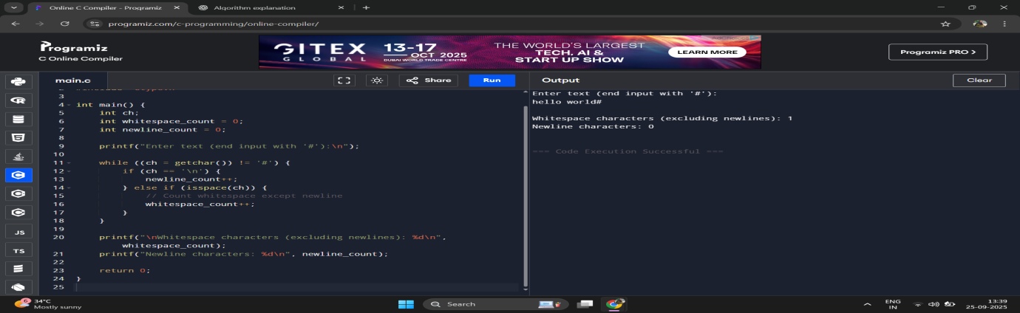

2. Design a lexical Analyzer to find the number of whitespaces and newline characters.

